
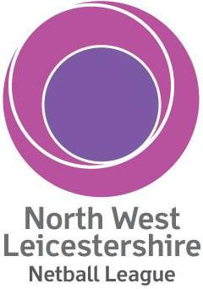
Tournament Entry Form
Date: Sunday 20th May 2018 at 9.00am
Venue: Ashby School, Nottingham Road, Ashby-De-La-Zouch, LE65 1DT
On the day, Optimum Performance will offer free injury rehab and sports massage
Families welcome with Bouncy Castle for children PLUS Raffle and refreshments including BBQ, & ice-cream
Closing Date: Monday 2 April 2018

Forms to be returned to: nwl.netball.league@gmail.com
or
Suzie Jacobs, 86 Suffolk Way, Church Gresley, DE11 9GL

Fee (£45 per team): Cheques payable to ‘NWL Netball League’
or
Bank transfer to HSBC Business Banking;
Account No: 81468294; Sort code: 401626

Name of club: ……………………………………………...........................................
Number of teams: ……………………………………………...........................................
Team names: ……………………………………………...........................................
Club contact details ……………………………………………...........................................
(address and tel no): ……………………………………………...........................................
Kit colours: ……………………………………………...........................................
Umpire name & contact details: ……………………………………………………………………………………..
Please note: If your players are not affiliated to England Netball, please ensure they sign the disclaimer. Each team will need a minimum of 7 players registered, there is no restriction on playing up or down in this tournament. Only those registered can play in your team, you can’t play for another team in the same tournament.
Any queries contact nwl.netball.league@gmail.com

