This form should be completed for all incidents, whether or not medical treatment is given, and filed for future reference. This is not an insurance claim form.

1. DETAILS OF PERSON INVOLVED
Name: |  |  |  | Netball Id
Full Address:
 |  |  |  | postcode:
Date of Birth |  | Occupation
Telephone(s)

2. WITNESSES if available
Name:
Full Address:
postcode:
Telephone(s)
Email

Name:
Full Address:
postcode:
Telephone(s)
Email

Name:
Full Address:
postcode:
Telephone(s)
Email

 | Type of activity at time of injury |  |  | Nature of Injury/Illness
 | training/practice |  |  | abrasion/graze
 | competition |  |  | sprain eg ligament tear
 | Other |  |  | strain eg muscle tear
 |  |  |  | open wound/laceration/cut
 | Reason for Presentation |  |  | bruise/contusion
 | new injury |  |  | inflammation/swelling
 | exacerbated/ aggravated injury |  |  | fracture (including suspected)
 | recurrent injury |  |  | dislocation/subluxation
 | illness |  |  | overuse injury muscle or tendon
 | other |  |  | blisters
 |  |  |  | concussion
 |  |  |  | cardiac problem
 |  |  |  | respiratory problem
 |  |  |  | loss of consciousness
 |  |  |  | unspecified medical condition
 |  |  |  | other

 | CAUSE OF INJURY/ Mechanism of Injury |  |  | Initial Treatment
 | struck by other player |  |  | none given (not required)
 | struck by ball or object |  |  | RICER
 | collision with player/umpire |  |  | sling, splint
 | collision with fixed object |  |  | massage
 | fall/stumble on same level |  |  | CPR
 | jumping to shoot or defend |  |  | strapping/taping only
 | fall from height |  |  | none given - referred elsewhere
 | awkward landing |  |  | dressing
 | overexertion (eg tear muscle) |  |  | Crutches
 | overuse |  |  | Manual therapy
 | slip/trip |  |  | Stretches/Exercises
 | temperature related |  |  | other
 | other |  |  | other
 | Was protective equipment worn on the |  |  | Treating person
 | injured body part? |  |  | medical practitioner
 | yes |  |  | physiotherapist
 | No |  |  | nurse
 |  |  |  | sports trainer
 |  |  |  | Other
Full Details of
Injuries
Details of Treatment
Received

ACCIDENT/INCIDENT
Event & Venue
Location within Venue
Date |  | Time

Description of
Incident

To support your description, you may wish to complete a diagram on a separate piece of paper.

3. DETAILS OF PROPERTY DAMAGE if applicable
Property Owner’s Name:
Full Address:
postcode:
Telephone(s)

Details of
Damage

5. ANY ADDITIONAL COMMENTS
Signature | …………………………………………………….. |  | Date | …………………………………...
Name | …………………………………………………….. |  | Your Netball Role at this Event | …………………………………...

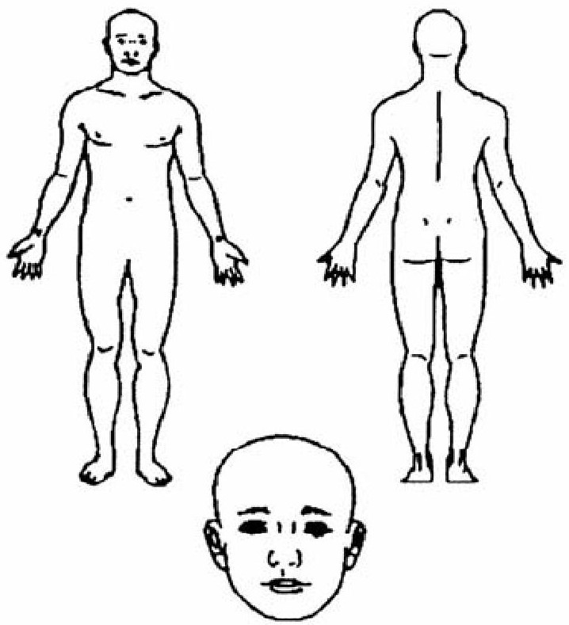 | Body Region Injured  Tick or circle body part/s injured & name

