North West Leicestershire Netball League
AGM
Monday 11th June 2018 Time 7pm
Venue: Best Western Appleby Park
Agenda:
- Present
All teams were represented
- Apologies
Committee member Hayley Homer and also LCNA Chair Kathy Stripp
- Minutes of last AGM
Proposed as a accurate record by Denise Bales, Ashby and seconded Charlotte Locker, Overseal.
- Matters arising from minutes of last AGM
Not matters arising
- Chair Report

- Secretary's Report
I only have a couple of things to inform you about.
1. Firstly, We are introducing a second venue for next Season, Ashby School. This is going to give us more scope to allow more teams to participate each season.
2. We are also in the process of updating the handbook,
• Cup and Plate Tournament which isn't currently in the handbook.
• Duel venue
• Match fees
• Team duties
• Safeguarding
These Items will all be finalised at the next committee meeting over the summer and sent out to all clubs at the start of the season.
3. Data protection & Privacy Policy
A new Data protection & Privacy Policy and been produced and will be sent out to your club contacts.
The NWL League requests your personal information through your club secretaries during the registration process. We will not share this information with any third parties without your express permission
There may be occasion where phone numbers, emails and names will be requested to be shared, this will only usually be for the club contacts, executive committee and registered umpires where by the smooth running of the leagues would benefit.
From last season we did find that having a whats app group with all the team captains in was very beneficial. It allowed requests and information to get to the teams straight away rather than on email. We would like to set this up again for this Season, one for Div 1 and one for Div 2. This would mean the captains mobile numbers would be requested and added to that group. This would mean that those numbers were being freely seen by all those in that group. The Team Captains are free to decline this request, but it may however hamper information getting though as quickly.
If anyone has any comments or suggestions regarding the Data protection laws within our league that they would like to share, please speak to me after.
- Treasurer’s Report
No monetary fees given out this year, and below is the accounts with a couple of outstanding fees to come out.
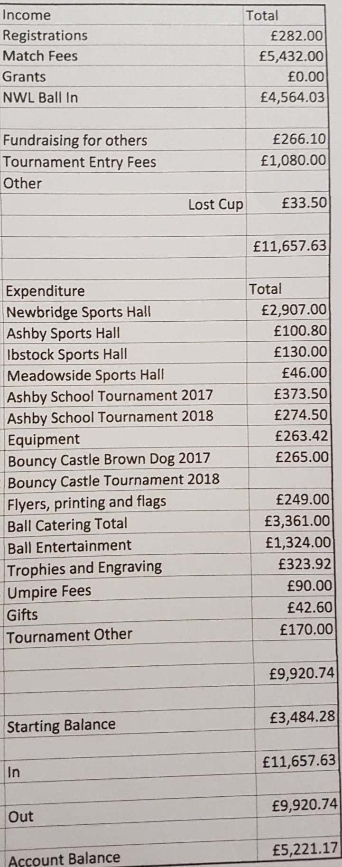
- Umpires Secretary Report
Before I start I would like to say a huge thank you to all our umpires this season, from the qualified to the mentored. This season we have been able to introduce mentored umpires into division 1 which has been a great experience in preparation for their C award. On that note I would like to wish Megan and Hayley all the best for their final assessment in the next few weeks. I would also like to wish all that have attended an into officiating or C award course good luck in their journey to becoming a qualified umpire. This takes me on to thank those who have took the time to help mentor some of our umpires.
Unfortunately Jo Stevenson has stepped down as her role as county Umpire Co-ordinator so until her role is filled assessments are on hold. I will still be communicating with Jo about upcoming courses for anyone else interested in becoming an umpire.
- Fixtures Secretary
- Registration Secretary Report
- Suggestions and Ideas
Loved the addition of the score board, feel it not only helped the players but it also meant that the umpires just had to focus on umpiring.
Nice to have match balls but is there any way that the condition of these can be monitored – sometimes these were not of a good playing standard and our own teams match ball was better – but we were not allowed to use it - THE UMPIRE WILL TAKE THE BALL AT THE END OF EACH QUARTER AND RETURN IT AT THE START OF THEM MATCH. ANY ISSUES WITH THE BALL WILL BE FED BACK TO THE COMMITTEE TO REPLACE.
Captains whatsapp was useful and a good way to keep in touch with other captains – especially when re-arranging games and also meant that all club contacts were readily available. - WILL DO THE SAME THIS SEASON
Found it unfair that we had to rearrange our own matches when they were cancelled by the league, granted this should be the case if we are cancelling however when they are cancelled due to the snow/court conditions, surely it is the responsibility of the league to make sure that these are rearranged. THE SNOW DAYS DID CAUSE SOME ISSUES, THE COMMITTEE ARE PUTTING SOME GUIDELINES IN PLACE FOR NEXT WINTER.
Toilet and changing facilities are still and issue – other leagues have these, why can’t NWLNL. It’s fairly basic to expect there be somewhere private to go to the toilet that has toilet roll and a non-see through door. - IT COMES AT AN EXTRA COST TO HIRE THE CHANGING ROOM, THE STAFF TOILET IS AVAILABLE AS WELL AS THE DISABLED TOILET.
- Election of Officers
Suzie has stepped down from registration secretary but stayed on as fixtures secretary, Katy and Nat have stepped down as ordinary members and Charlotte has took on the role of registration secretary. All other committee members were willing to stand in their roles again this season. Mandy Lines has joined as an ordinary member. Proposed by Rachel Ridgel, Grace dieu and seconded by Kelly White, Blaby.
- AOB
Val presented Denise Bales with an award from LCNA for being nominated for this year's Goalden globe.

