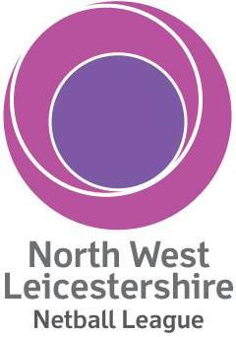 | OPTIMUM PERFORMANCE CUP  CAPTAIN’S ACCIDENT WAIVER AND RELEASE OF LIABILITY
I, as team captain, acknowledge that this athletic event is a test of a person’s physical and mental limits and carries with it the potential for death, serious injury and property loss. The risks include, but are not limited to: actions of other people including, but not limited to, participants, volunteers, spectators, coaches, event officials, event monitors and/or producers of the event; lack of hydration, weather, and/or other natural conditions. I hereby assume all of the risks of participating in this event on behalf of the team I am entering.

I certify that my team is physically fit, has sufficiently trained for participation in this event and have not been advised otherwise by a qualified medical person.

I acknowledge that this Accident Waiver and Release of Liability (AWRL) form will be used by NWL Netball League and the sponsors of the event in which my team may participate and it will govern my actions and responsibilities at said event.

In consideration of our application and permitting us to participate in this event, I hereby take action for myself, my executors, administrators, heirs, next of kin, successors, and assigns as follows: (a) Waive, release, and discharge from any and all liability for any team member’s death, disability personal injury, property damage, property theft or actions of any kind which may hereafter accrue to us or our traveling to and from this event, THE FOLLOWING ENTITIES OR PERSONS: NWL Netball League, England Netball and Optimum Performance and their directors, officers, employees, volunteers, representatives and agents, the event sponsors and event volunteers, (b) indemnify and hold harmless all entities or persons mentioned in this paragraph from any and all liabilities or claims made by other individuals or entities as a result of my actions during this event.

I hereby consent on behalf of my team to receive medical treatment that may be deemed advisable in the event of injury, accident, and/or illness during this event.

I understand that, at this event or related activities, our team will be photographed. I agree to allow my team’s photo, video, or film likeness to be used for any legitimate purpose by the event holders, producers, sponsors, organizers, and/or assigns.

This AWRL shall be construed broadly to provide a release and waiver to the maximum extent permissible under the applicable law.

I hereby certify that I have read this document and I understand its content.

Print Name
Signature |  | Date

