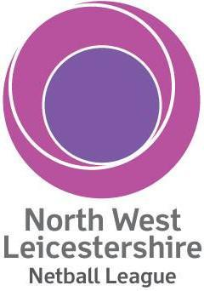 | OPTIMUM PERFORMANCE CUP  Under 16 PLAYER’S PARENTAL CONSENT
I, the undersigned parent or legal guardian of ___________________________________ (‘the Player’) grant permission for her participation in the North West Leicestershire Netball League’s (‘the NWLNL’) Optimum Performance Cup Tournament on Sunday 19 April 2020 at Ashby School, Ashby-de-la-Zouch, with ____________________________ team.
I understand that this is an adult netball league tournament. I fully release and exonerate Ashby School, the NWLNL, Leicester County Netball Association and England Netball, together with the officers, directors and members of the aforementioned entities, from any damages, injuries or losses, whether mental, physical or to personal property, while the Player is participating in the Tournament. I am aware that participation in sports and sports related activities or being present at a sports related activity exposes me and the Player to risk of physical injury by the nature of the sport and related activity.
I confirm that the Player is affiliated to England Netball, her affiliation number is: ___________________________ and her date of birth is ________________________.

I hereby certify that I have read this document and I understand its content.

Signature |  | Date
Print Name

